SCC Document Services
[ONSITE TECHNICIAN]

JOB TITLE: Onsite Technician
REPORTS TO: Regional Technical Manager
DEPARTMENT: SCC DS Technical Department
LOCATION: Various
KEY RELATIONSHIPS: Direct Line Manager, District Supervisors, Technical Planners

JOB PURPOSE
To provide technical support of Managed Print equipment onsite a client premises, ensuring that devices are repaired and maintained to SCC DS technical specification, and to provide basic end-user training and support where necessary.

ORGANISATIONAL CHART

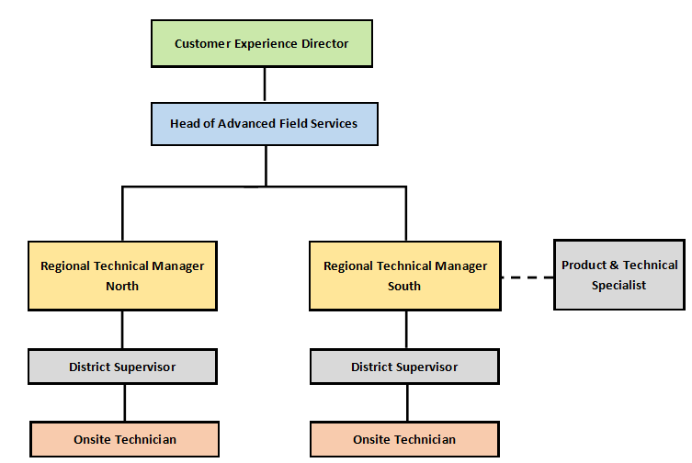

KEY RESULT AREAS
- Maintain and repair the full range of Ricoh, Canon, HP, MFP equipment in line with the published technical specification while adopting both SCC DS and client work methods and health and safety procedures
- Attend to field technical calls at client premises as directed by call control, responding to requests within the targeted response time and fix products on site efficiently and with minimum delay
- Ensure that accurate technical records are maintained by communicating with call control at required and appropriate times
- Organise and maintain a suitable vehicle or onsite spare parts kit to minimise Return to Fit [RTF] calls. Ensure that tools, technical manuals [including bulletins] and other equipment provided are available for use and in a complete and safe condition
- Ensure that, where provided, the company vehicle is maintained in line with published procedures and kept clean and presentable
- Maintain accurate work expense records and submit these, along with receipts, at the required time
- Attend technical training courses, seminars and other events including online training modules and exams to maintain technical skills and product awareness.

PERSON SPECIFICATION
Essential:
- Competent technician with extensive experience of repairing and maintaining colour and monochrome MFP devices including low, mid and high volume machines
- Connectivity experience [e.g. able to install print drivers & connect basic printer to simple network]

Desirable:
- Advanced IT networking / connectivity experience [e.g. set-up network scanning, full MFP installation on print server, etc.]

Behaviours:
- Must demonstrate a calm unflustered attitude and diplomatic approach
- Must adhere to all client processes and procedures whilst working on and attending site
- An analytical problem solving approach to difficult situations
- Good oral communication skills

