SCC Document Services
[FIELD TECHNICIAN]

JOB TITLE: Field Technician
REPORTS TO: Regional Technical Manager
DEPARTMENT: SCC DS Technical Department
LOCATION: Various
KEY RELATIONSHIPS: Direct Line Manager, District Supervisor, Technical Specialists, Technical Planner

JOB PURPOSE

To provide technical support for managed print equipment, ensuring that devices are repaired and maintained to SCC-DS’s technical specification, and to provide basic end-user training and support where necessary.

ORGANISATIONAL CHART

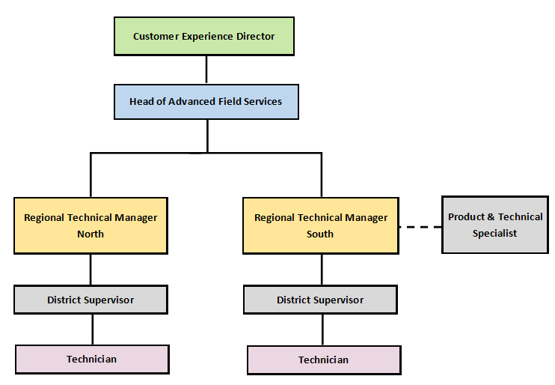

KEY ROLES

- Maintain and repair the full range of Ricoh, Canon, HP, MFP & Production Print equipment in line with the published technical specifications while adopting both SCC DS and client work methods and health and safety procedures
- Attend to field technical calls at client premises as directed by call control, responding to requests within the targeted response time and fix products on site efficiently and with minimum delay
- Ensure that accurate technical records are maintained via use of the PDA service support tools and by communicating with call control at required and appropriate times
- Organise and maintain a suitable vehicle or onsite spare parts kit to minimise Return to Fit [RTF] calls. Ensure that tools, technical manuals [including bulletins] and other equipment provided are available for use and in a complete and safe condition
- Maintain and manage Egnyte cloud-based digital document repository access via regular on-line synchronisation of provided laptop tools
- Ensure that, where provided, the company vehicle is maintained in line with published procedures and kept clean and presentable
- Maintain accurate work expense records and submit these, along with receipts, at the required time
- Attend technical training courses, seminars and other events including online training modules and exams to maintain technical skills and product awareness.
- Liaise and co-operate with other departments within SCC DS to promote an efficient level of operational service
- Communicate regularly within the Technical Department escalation channels regarding technical observations, in order to support any customer or equipment related issues or concerns, in order for corrective action to be taken

PERSON SPECIFICATION

Essential:
- Competent technician with extensive experience of repairing and maintaining colour and monochrome MFP devices including low, mid and high volume machines
- Connectivity experience [e.g. able to install print drivers & connect basic printer to simple network]
- High level of competency in relation to diagnostic fault finding
- DBS and SC Vetting will be a mandatory requirement for this role

Desirable:
- Advanced IT networking / connectivity experience [e.g. set-up network scanning, full MFP installation on print server, etc.]

Behaviours:
- Must demonstrate a calm unflustered attitude and diplomatic approach
- Must adhere to all client processes and procedures whilst working on and attending site
- An analytical problem solving approach to difficult situations
- Good oral communication skills
- Good interpersonal skills and the ability to communicate on all levels, even in situations of conflict
- Have a ‘Can Do’ attitude
- Full, Clean Driving Licence

